Chapter 4

Why do we need BaseEntity?
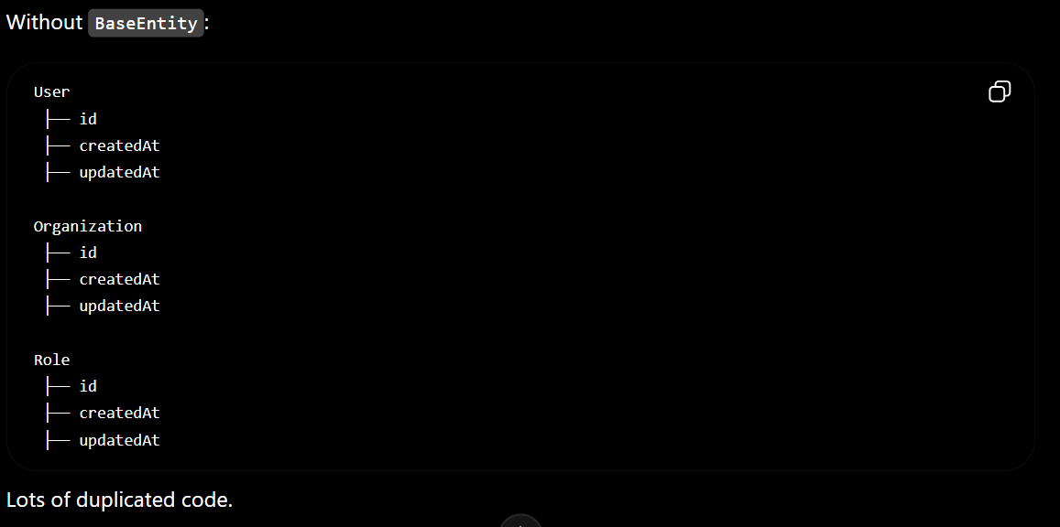
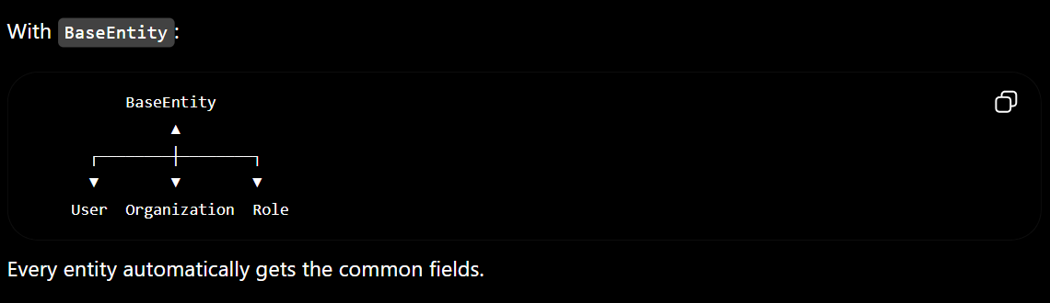

Fields in BaseEntity
Field | Purpose
id | Unique identifier (UUID)
createdAt | Record creation time
updatedAt | Last update time
createdBy | User who created the record
updatedBy | User who last updated it
version | Optimistic locking (prevents concurrent update conflicts)

Annotations Learned
Annotation | Purpose
@MappedSuperclass | Shares fields with child entities without creating a table
@Id | Marks the primary key
@GeneratedValue(strategy = GenerationType.UUID) | Automatically generates UUIDs
@Column | Maps Java fields to database columns
@Version | Enables optimistic locking
@Getter (Lombok) | Generates getter methods
@Setter (Lombok) | Generates setter methods

Lombok
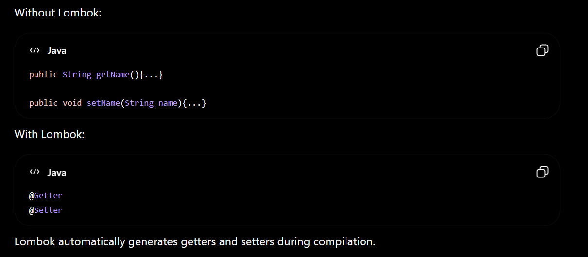
Best Practice
- ✅ Use @Getter and @Setter for JPA entities.
- ❌ Avoid @Data on JPA entities.

UUID
Instead of
1 , 2 , 3 …..
We use
550e8400-e29b-41d4-a716-446655440000
Benefits
- More secure
- Hard to guess
- Better for distributed systems
- Good for APIs and future microservices

@MappedSuperclass
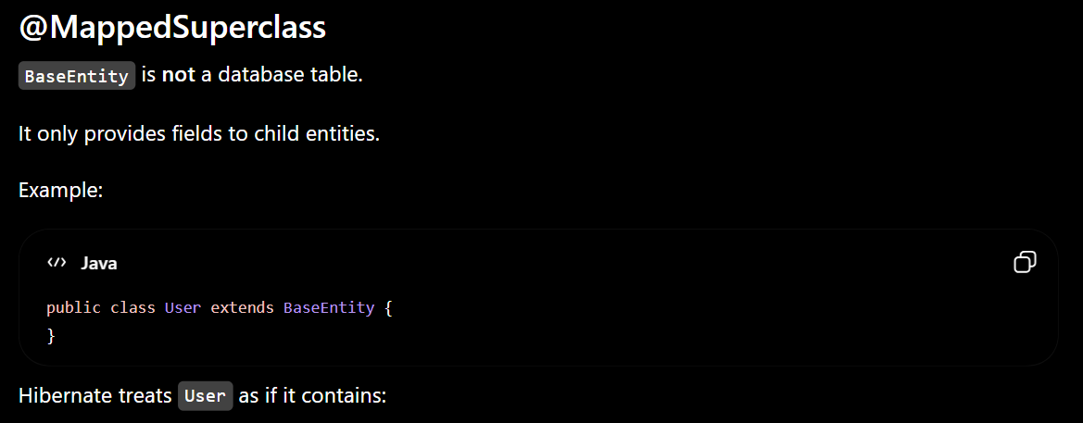
id
created_at
updated_at
created_by
updated_by
version

Project Structure
common/
└── entity/
└── BaseEntity.java
Quick Interview Notes
Question | Answer
Why use BaseEntity? | To centralize common fields (ID, audit fields, version) and avoid code duplication.
Why use @MappedSuperclass instead of @Entity? | Because BaseEntity is not a standalone table; it only shares its fields with child entities.
Why use UUID instead of Long IDs? | Better security, non-sequential IDs, and easier support for distributed systems and microservices.
Why use @Version? | To implement optimistic locking and prevent lost updates when multiple users modify the same record.
Why use Lombok? | To automatically generate boilerplate code such as getters and setters, making the code cleaner and easier to maintain.

